VISITING (INSERT SCHOOL HERE)?
- Please complete the process via the QR code below or by going to the CSBB Contractor & Volunteer Engagement Form.
- Ensure you select the correct category of contractor or volunteer.

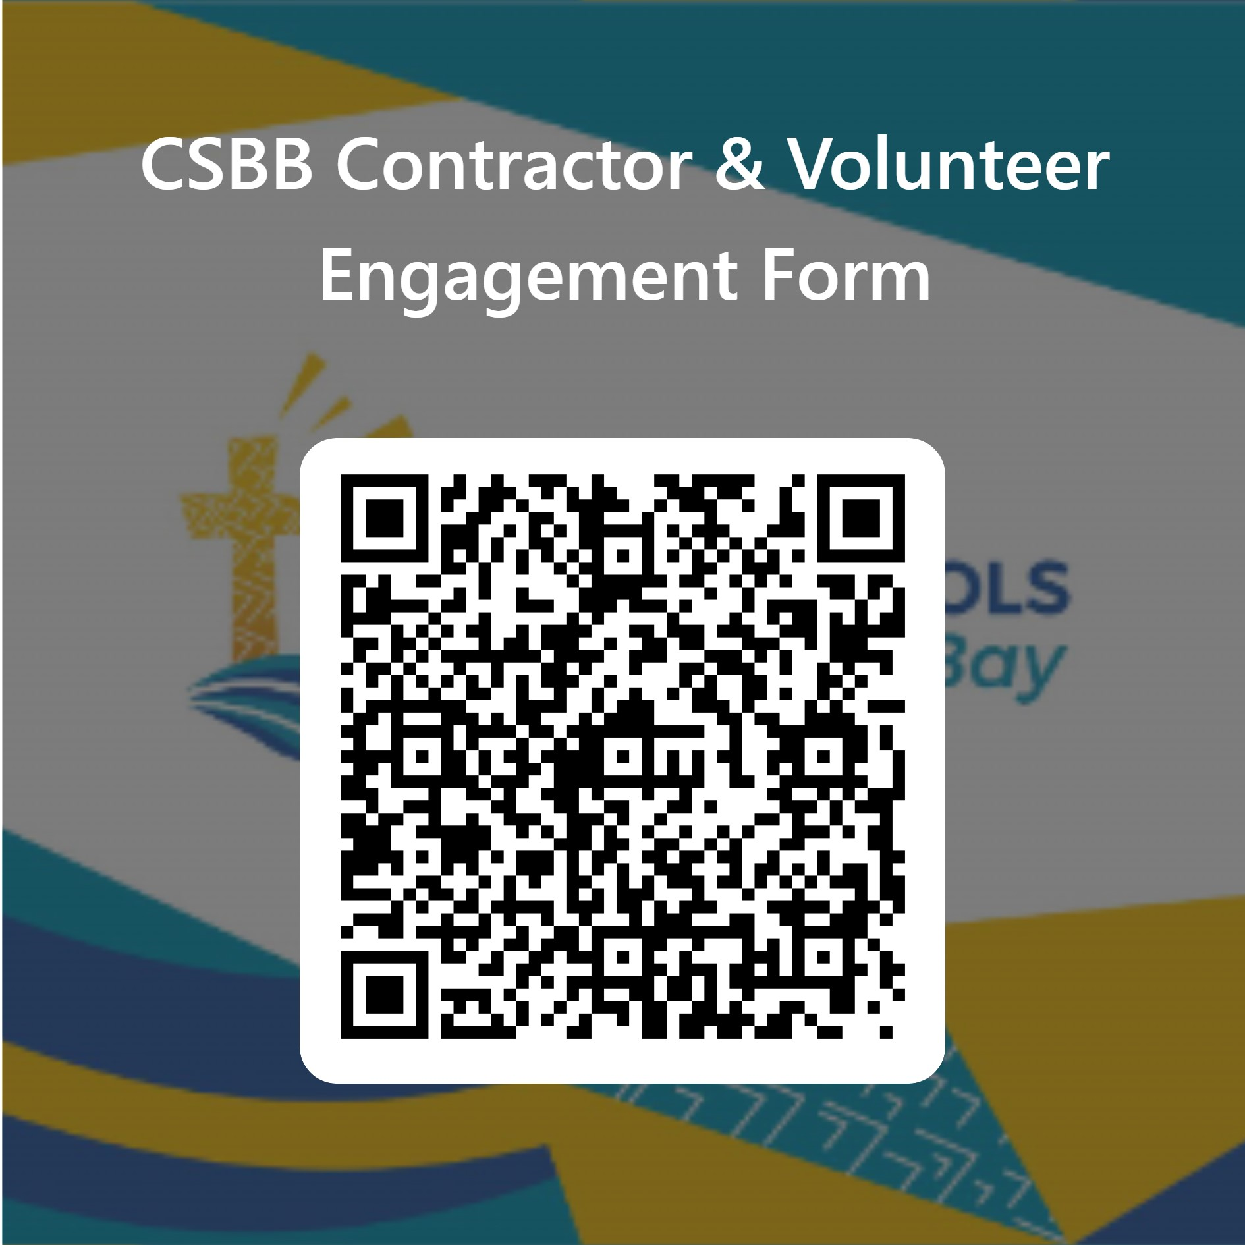

IMPORTANT POINTS TO NOTE REGARDING CONTRACTORS AND
WORKING WITH CHILDREN CHECKS
- If you are self-employed, CSBB will verify your WWCC and notify the school. You must show your identification upon arrival and the process is complete.

- If you are employed by an organisation, when you complete the QR code form;

- YOUR EMPLOYER will receive an email with details on how to return a WWCC verification directly to Catholic Schools Broken Bay (NOT the school) before you attend the site. Please ensure they read and action this email.
- This must be completed for you to be approved on the Safeguarding List. If you are not approved, you are not permitted to enter the school, there are no exceptions to this rule.
We thank you for your cooperation in keeping our children safe.

